Standard modification of cables and connectors
Customer name
Article number

Nanotec offers cable and connector assemblies starting at order quantities of 1 pc. Please enter the required modifications in the appropriate boxes, taking the specified tolerances into consideration.

Shorter or longer individual conductors/JST connector assemblies
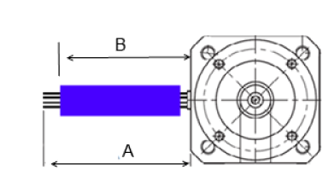 |  | 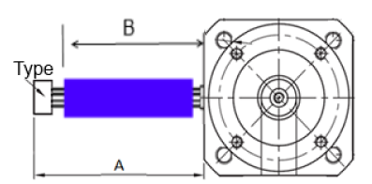
 |  |  |  |  | 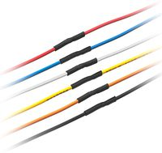

The individual conductors can be shortened or can be extended by soldering on stranded wires of the same color. In the case of extension, the transition is covered with heat-shrink or spiral tubing. 5 mm of insulation is stripped from the ends of the conductors.

When a connector is selected, the overall length including connector must be specified.

Length "A" (+/-5 mm) / length "B" (+/-5 mm)
A= |  |  | B= |  |  | mm
Type B= |  | Heat-shrink tubing* |  |  | Shrunk
 |  | Spiral tubing**
Connector type | For AWG size | Selection
JST-PHR | 26-28
JST-XHP | 26-28
JST-VHR | 22

* Heat-shrink tubing color: black; material: polyolefin
** Spiral tubing color: natural; material: PE

Note:
If you require a different cable assembly, please send a detailed drawing to our sales team: sales@nanotec.de

Delivery time:
If the required motor is in stock, the processing time will be approx. 1 week for 1-24 pcs. and approx. 2 weeks for 25 pcs. or more. You can check the currently available stock of motors on our website.

